CHAPTER 8: Forces, energy and motion
Worksheet 8.4

Inertia and motion
Student: Class:
1. State Newton’s First Law of Motion.

2. Consider the following examples of forces acting on a body. In each case find the net (unbalanced) force and describe the resulting motion of the object. Assume north is up the page.
(a)
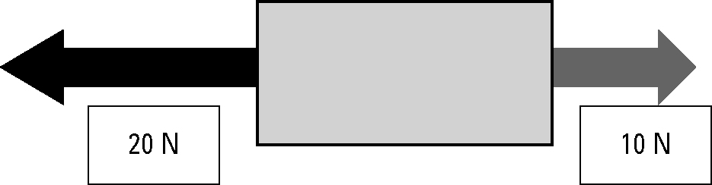
(b)
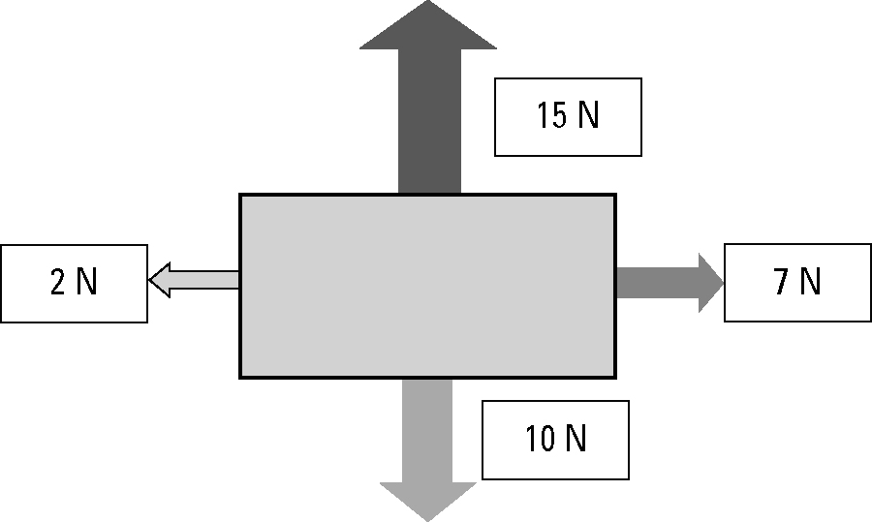
3. A 500-kg box is placed on the tray of a utility truck but is not secured by ropes. The ute drives along a highway, then the driver has to brake suddenly to avoid a wombat on the road. Use the concept of inertia to explain the danger to the driver.

4. A 1-kg pendulum is mounted on the roof of a vehicle as shown in the diagram.
 | 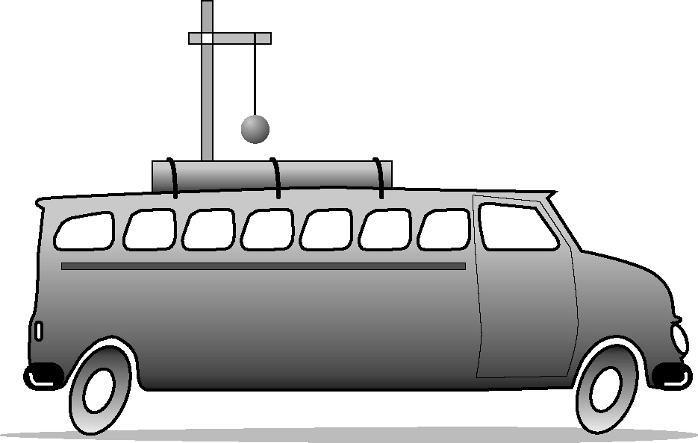 | Describe the motion of the pendulum for each example.  (a) The vehicle accelerates from rest.  (b) The vehicle brakes from a speed of  60 km/h.

